prof. dr Mira L. Zečević
Faculty of Pharmacy,
University Belgrade
Address: Vojvode Stepe 450, 11000 Belgrade
Phone (office): +381 11 3951-334; Mob. + 381 63 101 87 14
Fax: +381 11 3972 840
E-mail: mzecevic@ pharmacy.bg.ac.rs

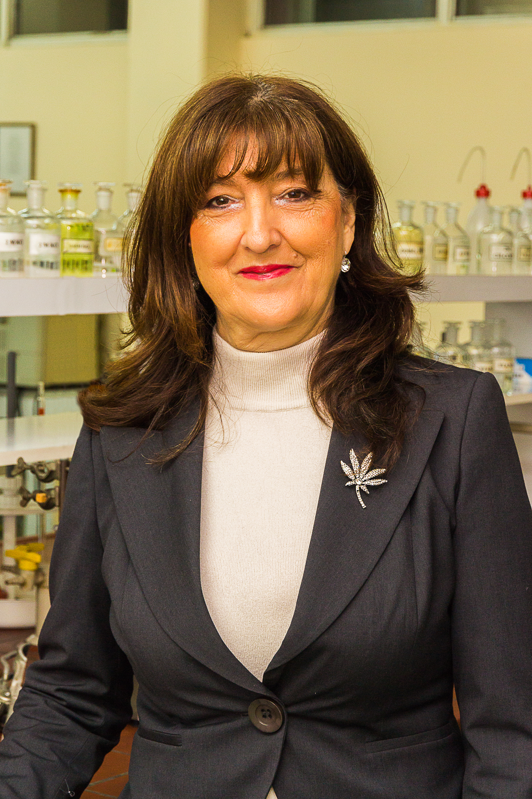

CURRICULUM VITAE
EMPLOYMENT:

2010. Full Professor
Institute of Pharmaceutical Chemistry and Drug Analysis
Faculty of Pharmacy, University of Belgrade

2004. Associate Professor
Institute of Pharmaceutical Chemistry and Drug Analysis
Faculty of Pharmacy, University of Belgrade

1999. Assistant Professor
Institute of Pharmaceutical Chemistry and Drug Analysis
Faculty of Pharmacy, University of Belgrade

EDUCATION:

2014.A Specialis in pharmacy

1998. Ph.D. of Sciences in Pharmacy
Faculty of Pharmacy, University of Belgrade

1992. M.A. degree of Sciences in Pharmacy
Faculty of Pharmacy, University of Belgrade

2002. A specialist in Drug Analysis and Quality Control
Faculty of Pharmacy, University of Belgrade

1988. - 1999. Research Assistant

1987. – 1988. Research Fellow

1987. Bachelor of Sciences in Pharmacy

Academic awards and distinctions:

1986. University's award.
2004. Award by the Ministry of Science and Technology of the Republic of Serbia a participant of the project named “Molecular structures, chemical transformations, physicochemical characterization, pharmaceutical purity, and analysis of pharmacologically active compounds” No. 1458 financed by the Ministry of Sciences and Technology of the Republic of Serbia.

Teaching activities:

Teoretical courses: Subjects
- Integrated academic studies – master of pharmacy
  - Pharmaceutical analysis (M)
  - Regulations in drug control (ES)
- Doctoral academic studies Pharmaceutical sciences – programme accredited 2020.; Subjects:
  - Communication and presentation skills (M)
  - Principles of modern drug analysis (ES)
  - Strategy development methods and chemometrics in drug analysis (ES)
  - Quantitative relationship of structure and system response in drug analysis(ES)
  - Selected chapters of analytics and bioanalytics(ES)

- Specijalistical academic studies – Drug release on the market
  - Active pharmaceutical substances and excipients (M)
  - Pharmaceutical analysis (M)
  - Chemometry in the manufacturing and control of drugs (ES)
- Postgraduate professional specialization – Drug Analysis and Quality Control:
  - Regulations in drug control (M)
  - Pharmaceutical analysis and drug control (M)
Guest Teacher on Faculty of Pharmacy University in Tuzla and Faculty of Pharmacy University in Bijeljina; Subjects: Analysis and drug control I; Analysis and drug control II.
She was a mentor of 15 specialist theses, 2 master's theses, 7 doctoral theses. She has mentored more than 30 graduate theses. She has numerous memberships in the commissions for the evaluation of doctoral dissertations, master's and specialist as well as graduate theses.

Textbooks:

1. PRAKTIKUM SPEKTROFOTOMETRIJA U ANALITICI LEKOVA, Naučna knjiga 1993.godine
Darko Ivanović, Snezana Agatonović-Kuštrin, Mira Vasiljević

2. ANALITIKA LEKOVA
Darko Ivanović, Beograd, 2004
Darko Ivanović, Mira Zečević, Anđelija Malenović

3. ODABRANA POGLAVLJA FARMACEUTSKE REGULATIVE U KONTROLI LEKOVA, Univerzitet u Beogradu-Farmaceutski fakultet, 2017.

Activities within the Faculty of Pharmacy:

2017.-2021. Head of Laboratory of drug analysis
2013. Head of Department for Drug analysis
2012.-2017. Member of Programme's Board Centre for continuous education
2012. Member of Committee for postgraduate study – specialization study
2012. Leader of postgraduate stady programe Release of medicinal products
2012.-2020. Leader of postgraduate stady programe Drug Analysis and Quality Control:
2012. A member of Faculty’s Board.
2006. - 2012. vice dean for postgraduate stady
and continuous education on Faculty of pharmacy University of Belgarde.

2001-2006. a member of Committee for doctoral study

Activities within wider Academic Community:
2004. A member of the New York Academy of Sciences
1998. a member of the Pharmaceutical Society of Serbia
1998. a member of Section for Drug Analysis and Quality Control
2007-2014.Guest Teacher on Faculty of Pharmacy University in Tuzla and Bijeljina
2015-2020.Guest Teacher on Faculty of Pharmacy University in Bijeljina

Review activities: Reviewer for the next journals: Journal of Pharmaceutical and Biomedical Analysis, Journal of Chromatography A, Journal of Chromatography B, Chromatographia, Talanta, Journal of Association of Analytical Communities (AOAC), Journal of Serbian chemical society, Acta Chromatographica, Arhiv za farmaciju

Projects:
2010 – 2014. a participant on the project "Synthesis, Quantitative Structure/Properties and Activity Relationship, Physical-Chemical Characterization and Analysis of Pharmacologically Active Substances" No. 172033, financed by the Ministry of Education and Science of the Republic of Serbia.
2010. – 2012. a participant on the TEMPUS project „Postgraduate Qualification in Pharmacy - The Way Forward” financed by EU. Project coordinator Faculty of Pharmacy University of Belgrade.

2006.-2010. a participant on the project named "Synthesis, Quantitative Structure/Properties and Activity Relationship, Physical-Chemical Characterization and Analysis of Pharmacologically Active Substances" No. 142071 B, financed by the Ministry of Science and Technology of the Republic of Serbia.

2003-2006. A participant of the project named “Molecular structures, chemical transformations, physicochemical characterization, pharmaceutical purity, and analysis of pharmacologically active compounds” No. 1458 financed by the Ministry of Sciences and Technology of the Republic of Serbia.

Publications:

- Mitrović M, Protić A, Malenović A, Otašević B, Zečević M. Analytical Quality by Design development of an ecologically acceptable enantioselective HPLC method for timolol maleate enantiomeric purity testing on ovomucoid chiral stationary phase. J Pharm Biomed Anal 2020; 180: 113034. (Chemistry, Analitical, IF 3,209, M22)
- Krmar Jovana S,Protic Ana D,,Dajic Nevena, Zecevic Mira L,Otasevic Biljana M, Chromatographic and computational lipophilicity assessment of novel antibiofilm agents (Article; Early Access), Journal of Liquid Chromatography& Related Technologies, (2020), vol. 43:615-623
- Krmar Jovana S,Vukicevic Milan,Kovacevic Ana V,Protic Ana D, Zecevic Mira L,Otasevic Biljana M, Performance comparison of nonlinear and linear regression algorithms coupled with different attribute selection methods for quantitative structure - retention relationships modelling in micellar liquid chromatography (Article), Journal of Chromatography A, (2020), vol. 1623: 461146
- Otašević B, Šljivić J, Protić A, Maljurić N, Malenović A, Zečević M. Comparison of AQbD and grid point search methodology in the development of micellar HPLC method for the analysis of cilazapril and hydrochlorothiazide dosage form stability. Microchemical J. 2019; 145: 655-663 (Chemistry, Analitical, IF 3,594, M21)
- Sljivic Jasmina, Protic Ana D,Otasevic Biljana M,Golubovic Jelena B, Zecevic Mira L, Krmar Jovana S, Multicriteria Optimization Methodology in Stability-Indicating Method Development of Cilazapril and Hydrochlorothiazide (Article), Journal of Chromatographic Science, (2017), vol. 55 br. 6, str. 625-637
- Šljivić J, Protić A, Malenović A, Otašević B, Zečević M. Simple and efficient solution for robustness testing in gradient elution liquid chromatographic methods. Chromatographia 2018 August; (81): 1135-1145. (Chemistry, Analitical, IF 1.552, M23)
- Jelena Golubović, Ana Protić, Mira Zečević, Biljana Otašević, Ljiljana Živanović. Quantitative structure–retention relationships of azole antifungal agents in reversed-phase high performance liquid chromatography. Talanta 2012; 2012; 100:329-37.
- Svetlana Milovanović, Biljana Otašević, Mira Zečević, Ljiljana Živanović, Ana Protić. Development and validation of reversed phase high performance liquid chromatographic method for determination of moxonidine in presence of it's impurities. Journal of Pharmaceutical and Biomedical Analysis 2012; 59: 151-156.
- Biljana Jocić, Mira Zečević, Ljiljana Živanović, Ana Protić, Milka Jadranin, Vlatka Vajs. Study of forced degradation behavior of Eletriptan hydrobromide by LC and LC–MS and development of stability-indicating method, Journal of Pharmaceutical and Biomedical Analysis, (2009), v. 50 br. 4, 622-629.
- M. Zečević, Lj.Živanović, Ž. Stanković, B. Jocić.Validation of a high-performance liquid chromatographic method for the simultaneous determination of tramadol and its impurities in oral drops as a pharmaceutical formulation, Journal of Chromatography A, 1119 (2006), 251-256

